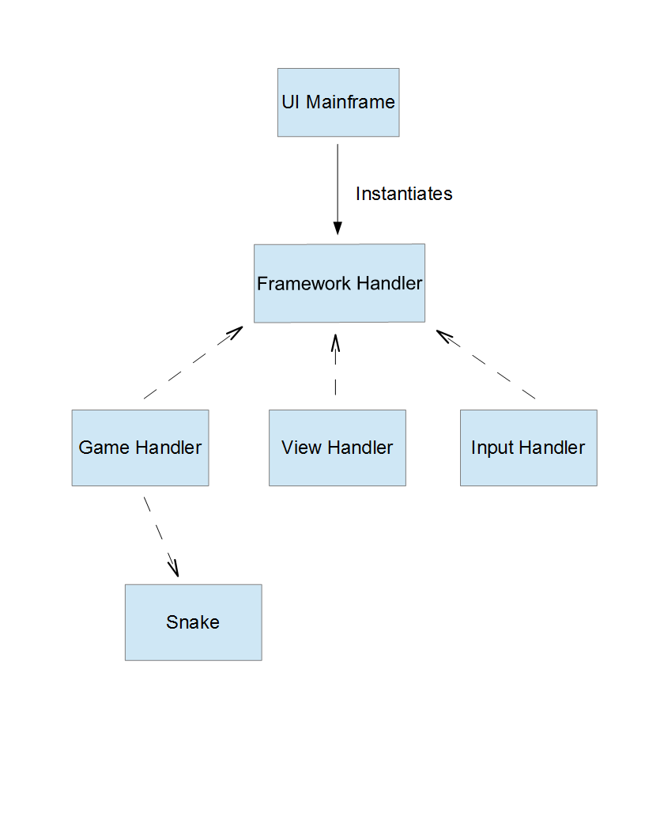

|  |  |
| --- | --- |
| UI Mainframe |  |
| * Create Menu * Create/Display View * Create Framework Handler | * Framework Handler |

|  |  |
| --- | --- |
| Framework Handler |  |
| * Create a New Game * Exit Apps * Create Input Thread | * Game Handler * Input Handler * View Handler * UI Mainframe |

|  |  |
| --- | --- |
| Game Handler |  |
| * Start Game * End Game * Create Snake * Check Snake * Move Snake * Keep Score * Terrain Tracking | * Snake * Framework Handler |

|  |  |
| --- | --- |
| View Handler |  |
| * Resume Game * Pause Game * Destroy View | * Framework Handler |

|  |
| --- |
| Input Handler |
| * Listen/Store Device Orientation |

|  |
| --- |
| Snake |
| * Store Snake Size/Positions |